

**Penetration Testing Report**

**(Metasploitable2)**

**Submitted by:**

|  |
| --- |
| **Names** |
| **Shady Mohamed Abdel Gawad** |
| **Hussein Al-Yamnii Zain Al-Deen** |
| **Ziad alaa** |
| **Mohamed Ashraf Mohamed Lotfy** |
| **Omar Ahmed Badr** |
| **Abdel Rahman Ahmed Abdel Hamid** |

**Under the supervision of:**

**Eng. Khaled Taha**

**Metasploitable Vulnerabilities Report**

**Executive Summary:**

**A vulnerability assessment and penetration test were conducted on one domain Metasploitable 2 to determine its exposure to a targeted cyber-attack. All tests were conducted in a manner that simulated a malicious attacker engaged in a cyber-attack against Metasploitable 2 with the following goals,**

**• Identify whether a remote attacker can penetrate defenses of Metasploitable 2.**

**• Determine the impact of a security breach of confidentiality and integrity of the**

**private data of the system, availability of information systems of Metasploitable 2 and internal infrastructure.**

**Security vulnerabilities that might give a remote attacker unauthorized access to sensitive data have been identified and exploited**

**Scope:**

|  |  |
| --- | --- |
| **IP address** | **192.168.21.129** |
| **Name** | **Metasploitable 2.0** |
| **System Type** | **Host** |
| **OS Information** | **Ubuntu 8.04 (hardy) on Linux kernel 2.6** |

**Methodology:**

**Penetration testing tools and frameworks were used for the vulnerability assessment and penetration test including Nmap, Nessus Metasploit Framework, various information gathering tools, Kali Linux penetration testing tools and automated vulnerability scanners.**

**Summary of Findings:**

|  |  |  |  |
| --- | --- | --- | --- |
| **No** | **Vulnerability** | **Risk** | **Testing scale** |
| **1)** | **SMTP (port 25/tcp)** | **Medium** | **Exploited** |
| **2)** | **HTTP (port 80/tcp)** | **Medium** | **Exploited** |
| **3)** | **VNC (port 5900/tcp)** | **High** | **Exploited** |
| **4)** | **MySQL (port 3306/tcp)** | **High** | **Exploited** |
| **5)** | **PostgreSQL (port 5432/tcp)** | **High** | **Exploited** |
| **6)** | **FTP (port 21/tcp)** | **High** | **Exploited** |
| **7)** | **SSH (port 22/tcp)** | **Medium** | **Exploited** |
| **8)** | **Telnet (port 23/tcp)** | **High** | **Exploited** |
| **9)** | **Apache Tomcat (port 8180/tcp)** | **Critical** | **Exploited** |
| **10)** | **Samba smbd 3.X (port 139/tcp)** | **High** | **Exploited** |
| **11)** | **Java RMI Server (Remote Method Invocation)** | **High** | **Exploited** |
| **12)** | **Backdoor in IRC (port 6667/tcp)** | **High** | **Not Exploited** |
| **13)** | **Bindshell (port 1524/tcp)** | **High** | **Exploited** |

**Installation of Machine:**

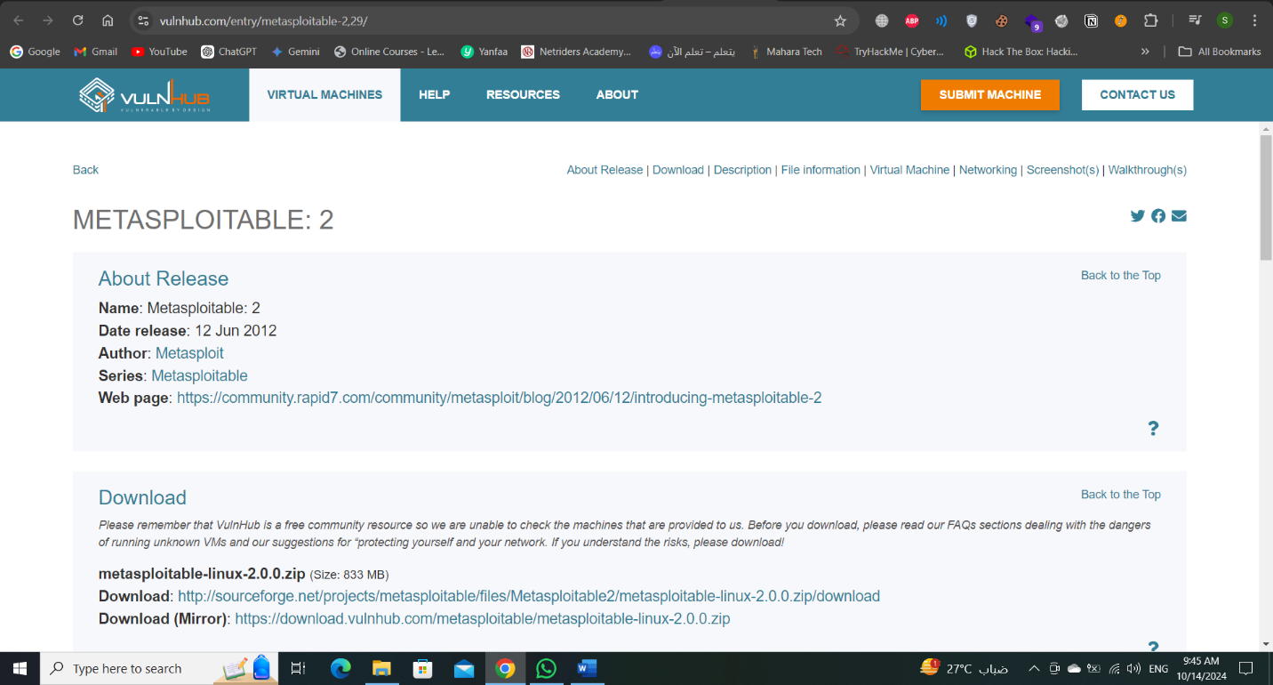**We should have VirtualBox or VMware to install on it the machine that it became the target and should download metasploitable from VulnHub and download the mirror version to apply the penetration testing phase.**

**After downloading this version, go extract the file to get the files.**

**After this Operation, we should open the VirtualBox or VMware to install and open the machine to work**

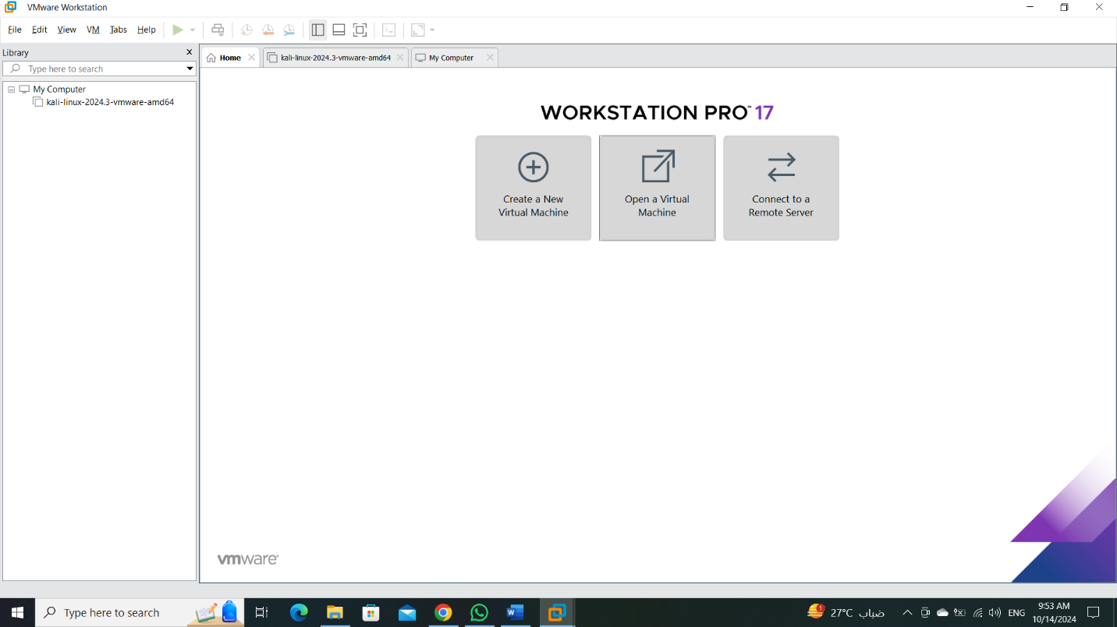**In home page , enter into “Open a Virtual Machine” and go to the path that the machine save in it and open the “.vmdk” format.**

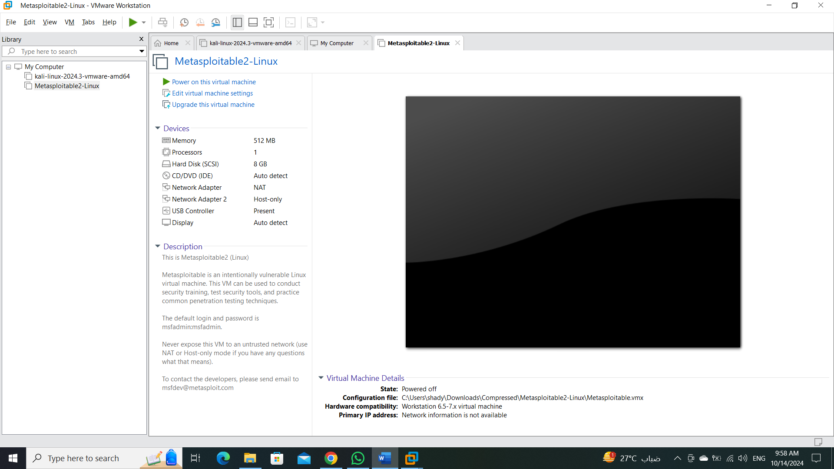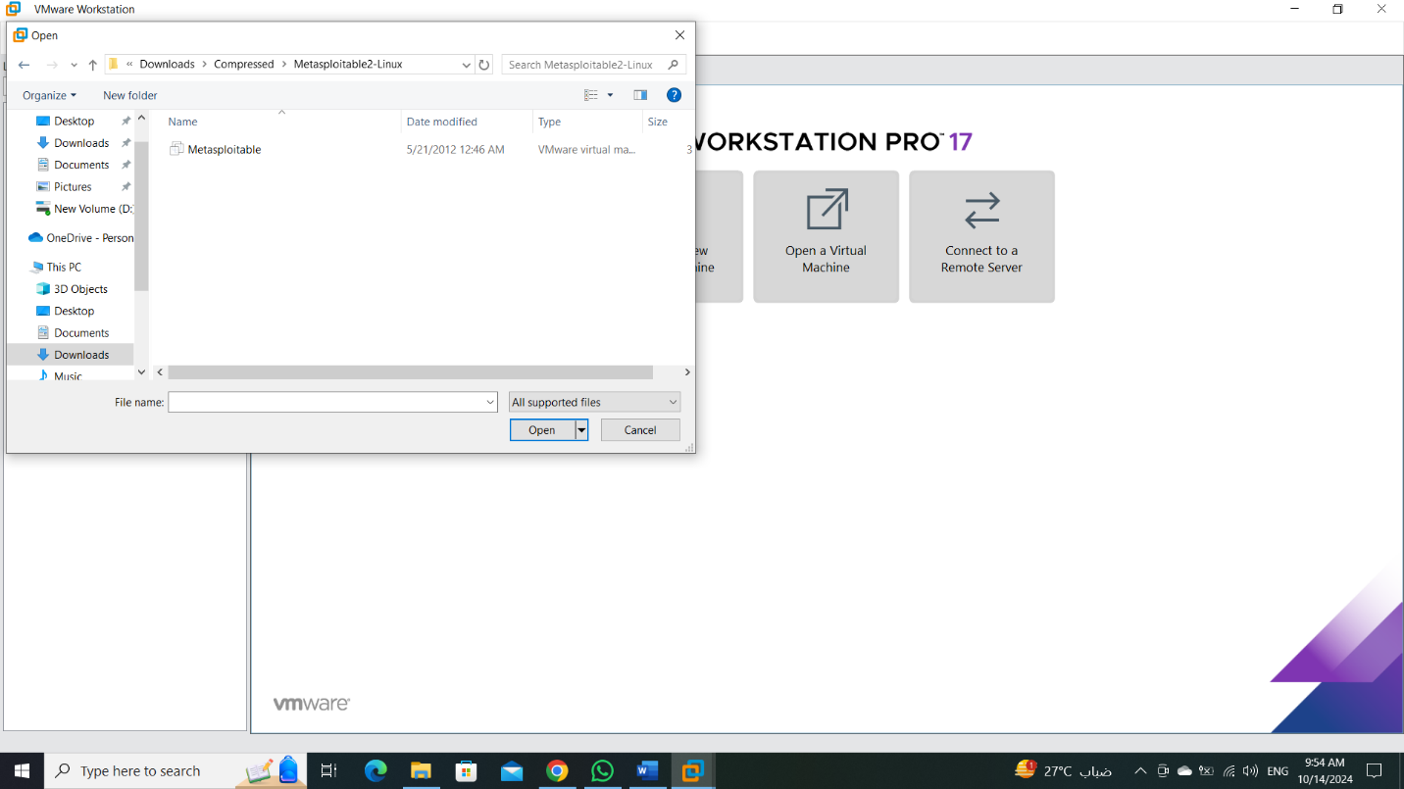

**We successfully install the machine and now we start to work on it.**

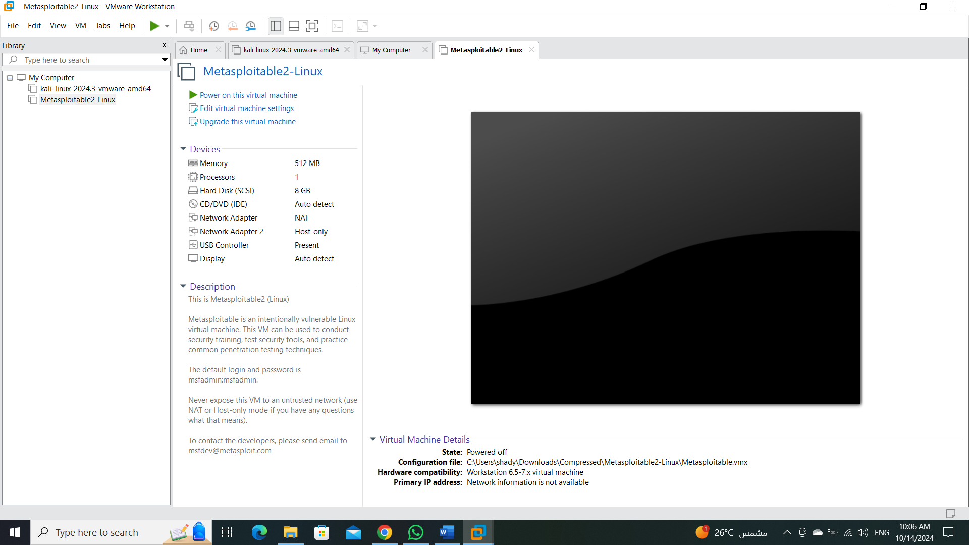**We should open the machine and discovery it to understand what is it.**

**Once opened, it asks for a login, and it might be difficult, but the credentials (msfadmin/msfadmin) are provided in the last line, and we must take these credentials and log in with them so that we can deal with the machine, and also so that the machine can take an IP address and appear on the Internet, and thus I can carry out the Penetration testing phases with ease.**

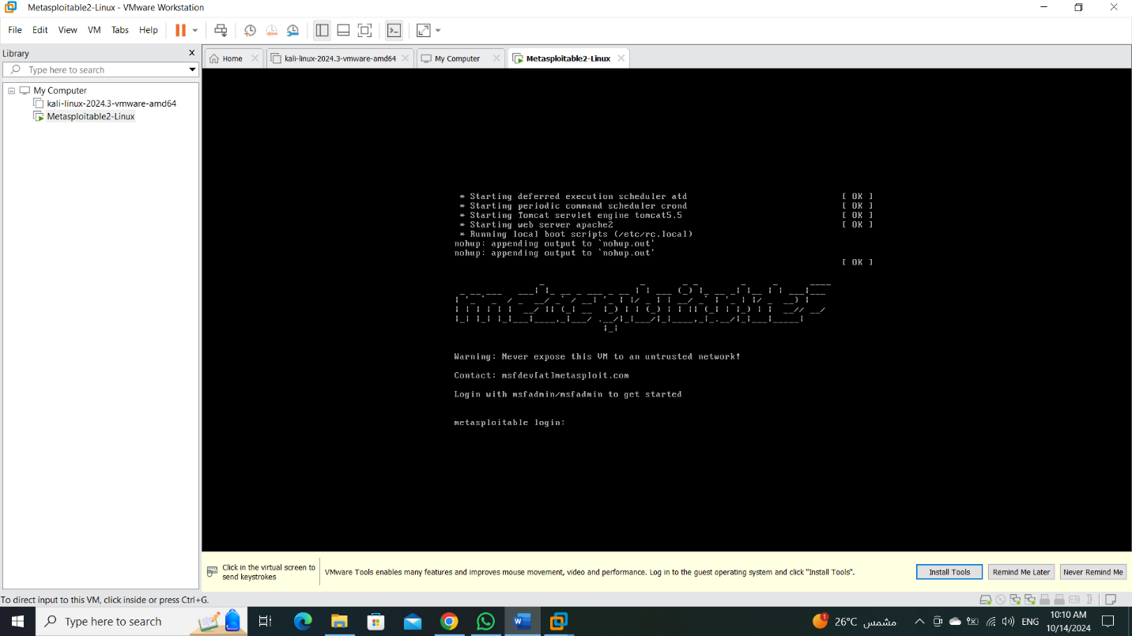

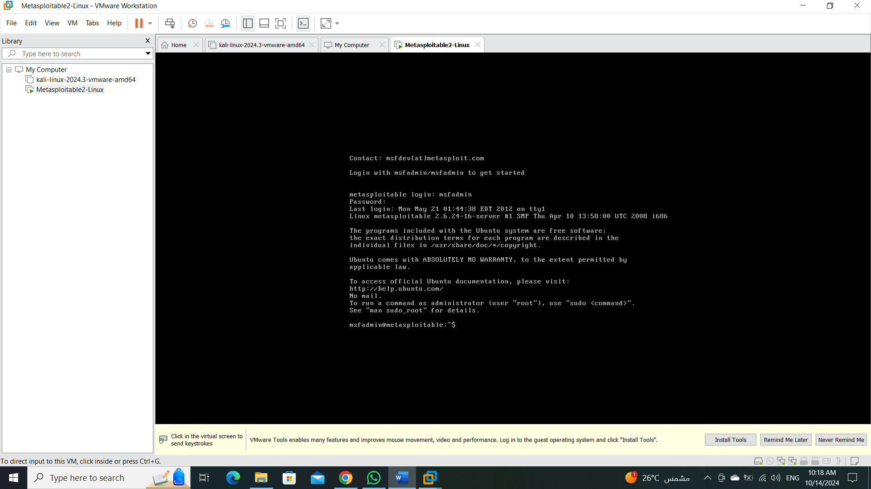**Once the machine is opened, we can go to Kali Linux to start working.**

**Phase 1: Footprinting and Scanning:**

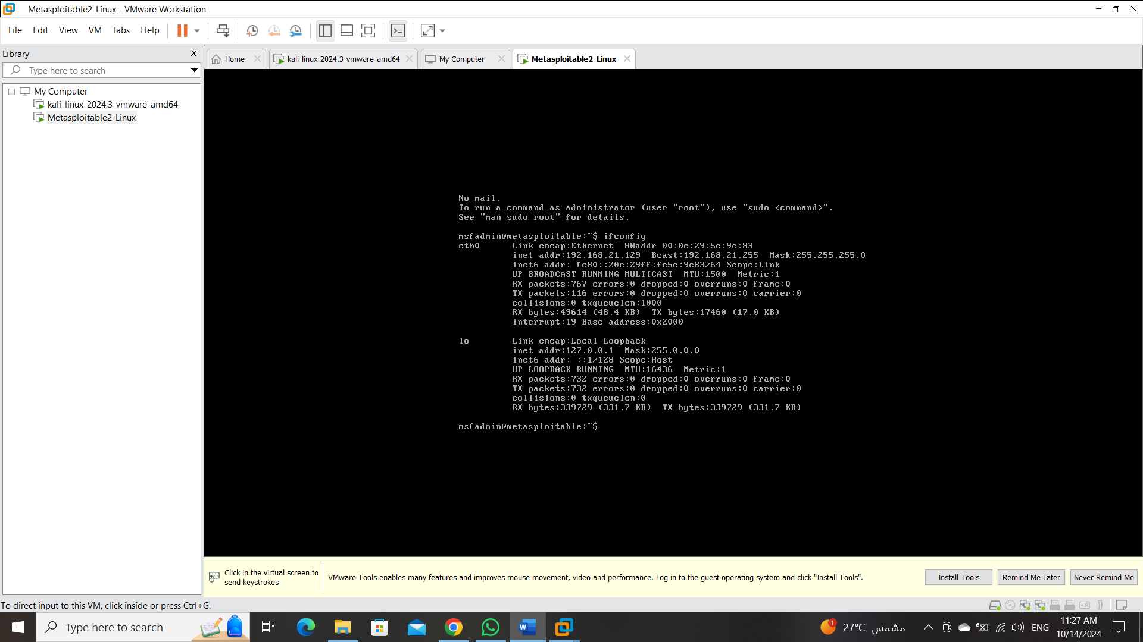**To know the IP address of the machine, we enter the “ifconfig “command to show the IP to help us to make scanning and another operation.**

**We found the IP address => 192.168.21.129**

**And this IP address< we use to make the Footprinting and Scanning.**

**Let’s get things started with a simple Nmap scan.**

**. Nmap -sV 192.168.21.129**

**“The -sV option in Nmap is used to perform version detection on open ports and when you use -sV, Nmap tries to determine the versions of the services running on those ports and in some cases, the service version may also provide clues about the operating system.**

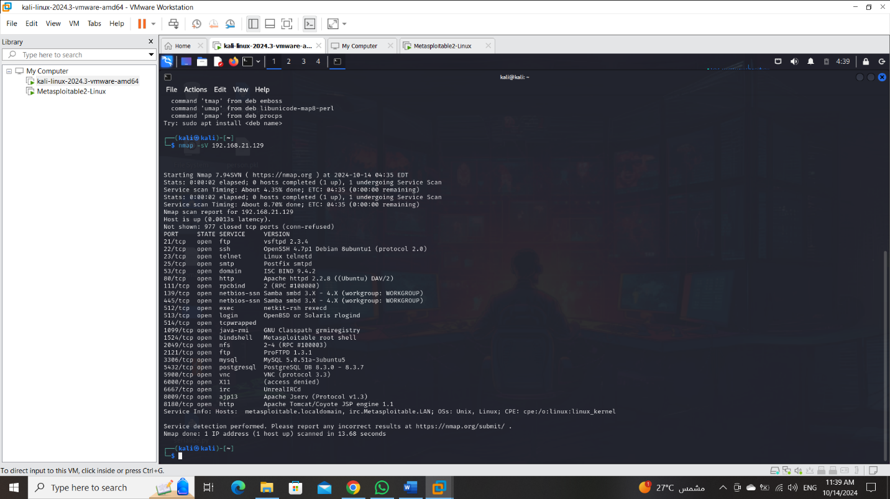

**Now, we find many ports opened like FTP, SSH, HTTP and …. etc.**

**After that, we will try to assessment all of the vulnerabilities to make sure the riskiness of each vulnerability to decision which vulnerability that more riskiness to exploit it in the exploitation phase.**

**Phase 2: Vulnerability Assessments:**

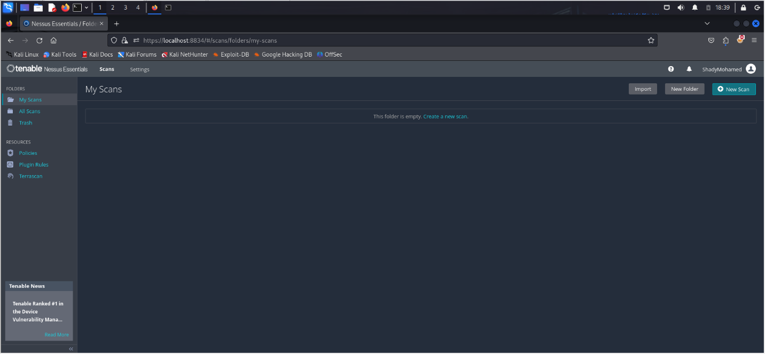**In the first, we need to install Nessus in the localhost and use it to assessments the vulnerability.**

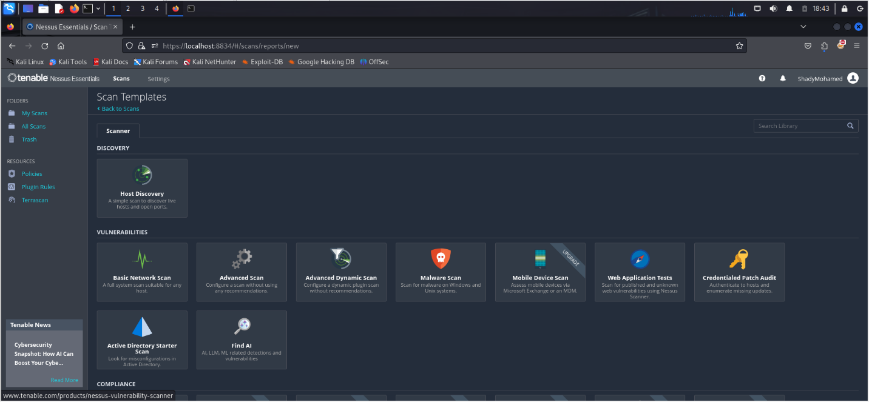

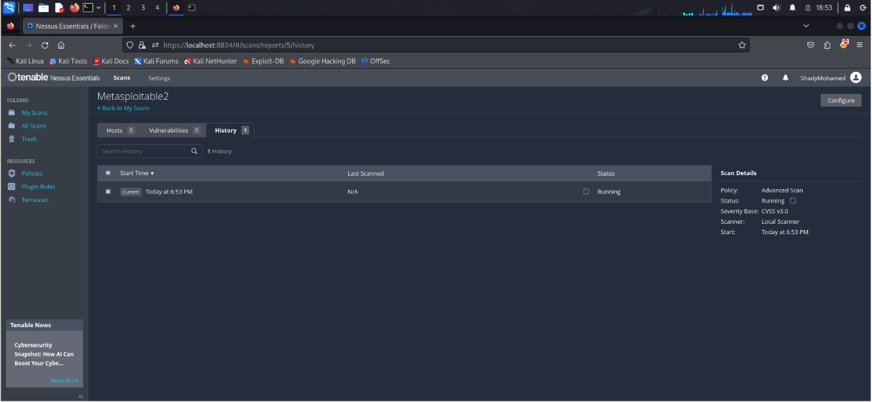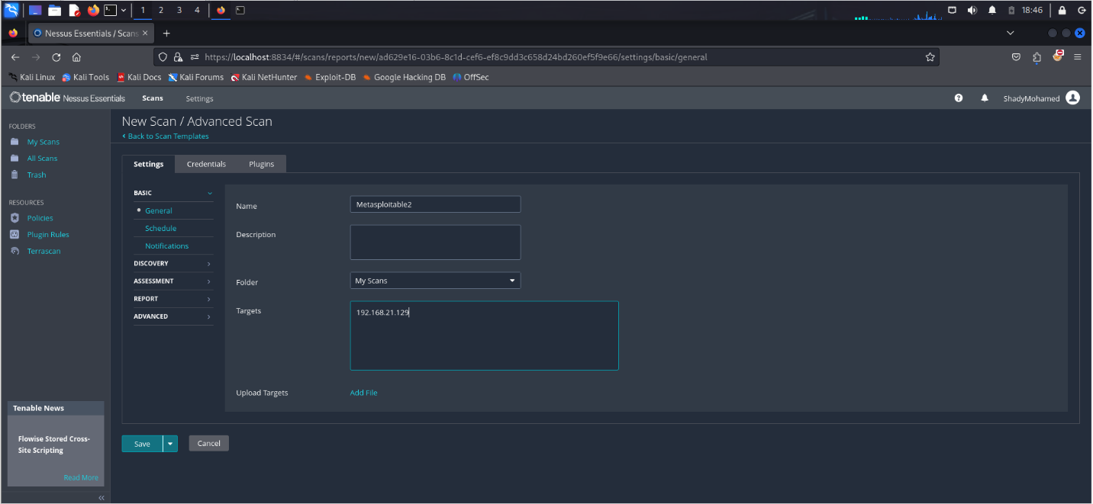

2

3

1

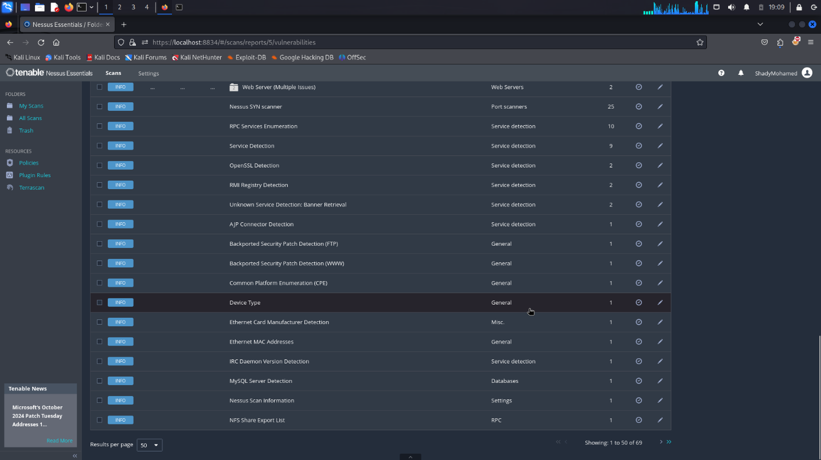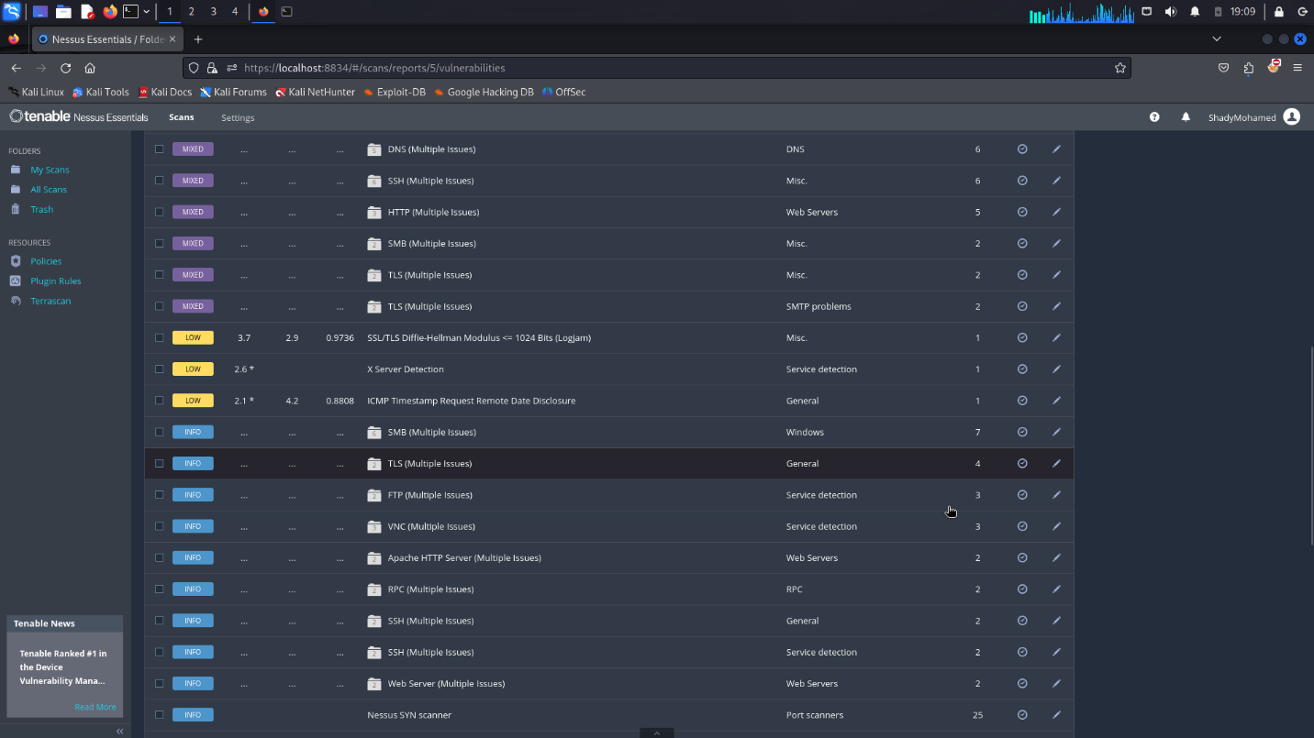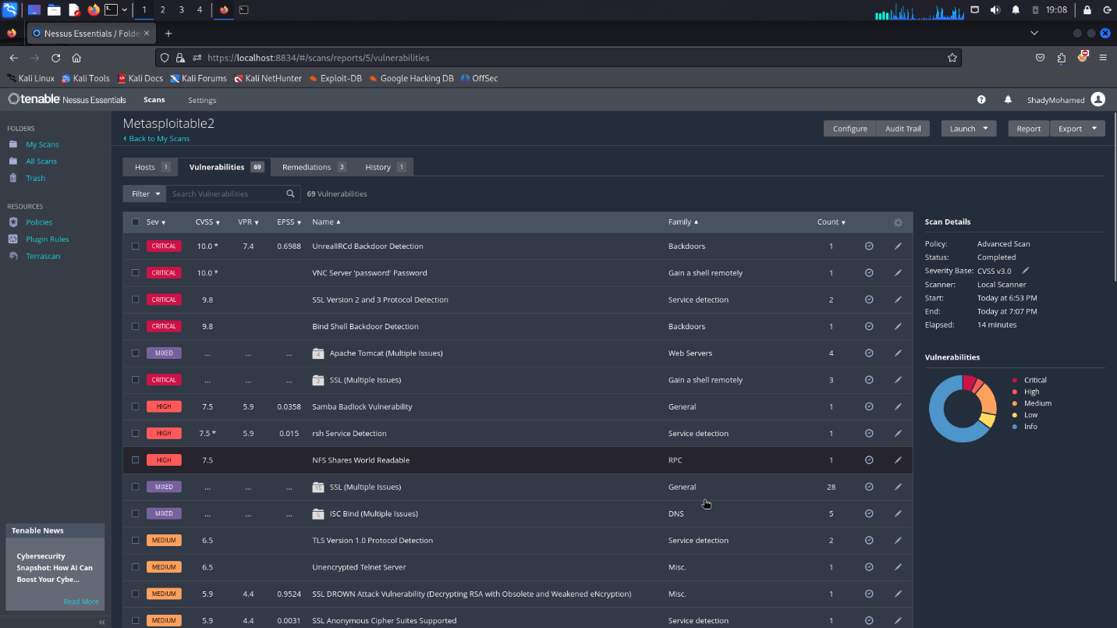

**After that assessment, we found that there are more than 60 Vulnerabilities between info, low, medium, high and critical.**

**So, in the exploitation phase-in the first- we focus on critical vulnerability and go to high and so on.**

**And we found that critical vulnerabilities make more damage in the system so we try to exploit those vulnerabilities to show how this damage can occur, and we try to find the mitigation of each vulnerability to fix this issue that it is caused.**

**Phase 3: Exploitation:**

**In this phase, we try to exploit each ports that see in the scanning phase. In the following, we show the vulnerability and its exploitation of this.**

1. **SMTP on port 25/tcp:**

**We try to use how SMTP enumeration scanner and what that does is it allows you to look for a valid for user account then we could potentially crack the passwords and have authenticated access to an SMTP server all right, so to do this we’re going to use Metasploit.**

**We use grep to show the scanner type and then we’re going to search SMTP.**

**And after this, we use the smtp_enum.**

**We should show option because sometimes we find the options that are required to make the exploit.**

**We found “RHOST” that required and no value in here, so we should set the “RHOST” option by the target machine.**

**And exploit this payload.**

**This problem may allow an attacker to steal a victim’s emails.**

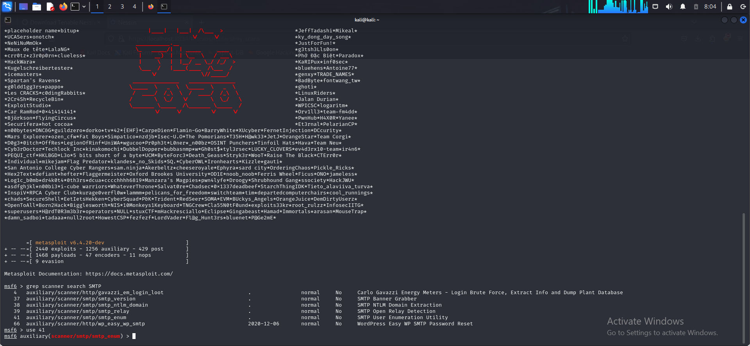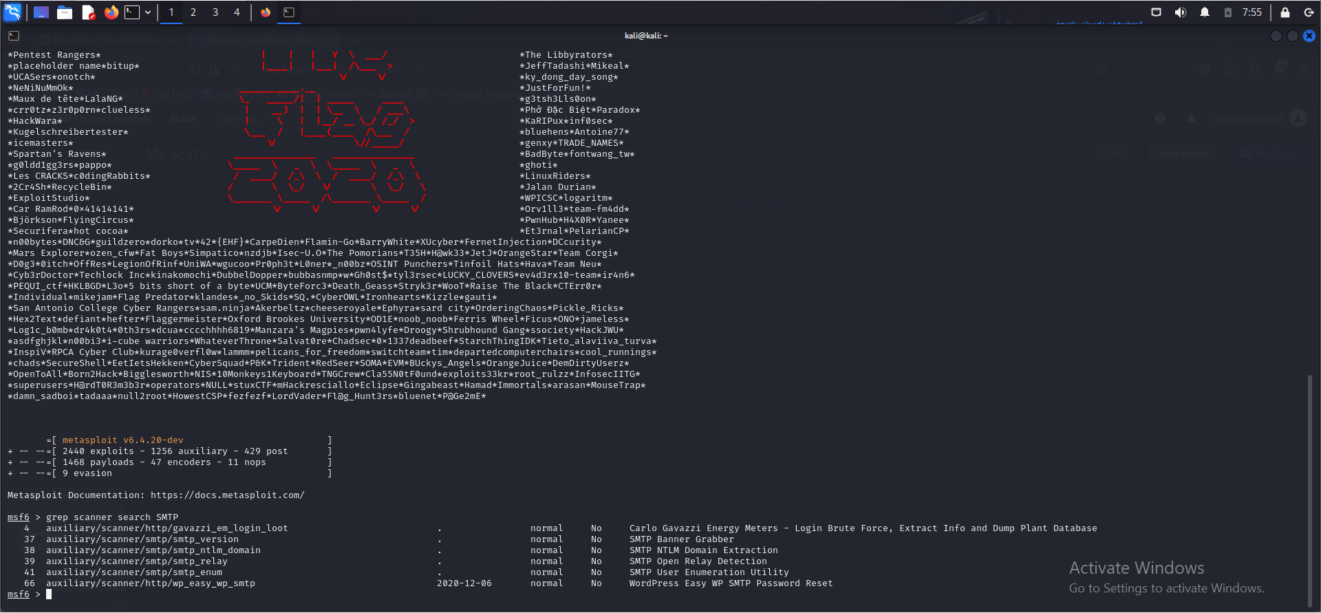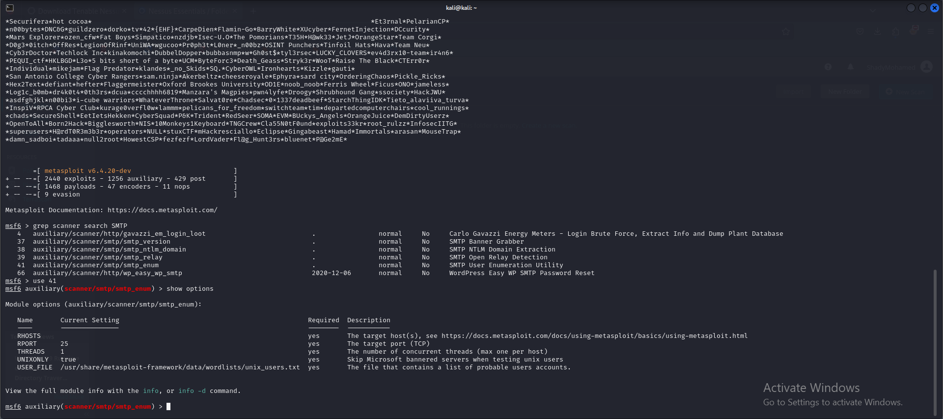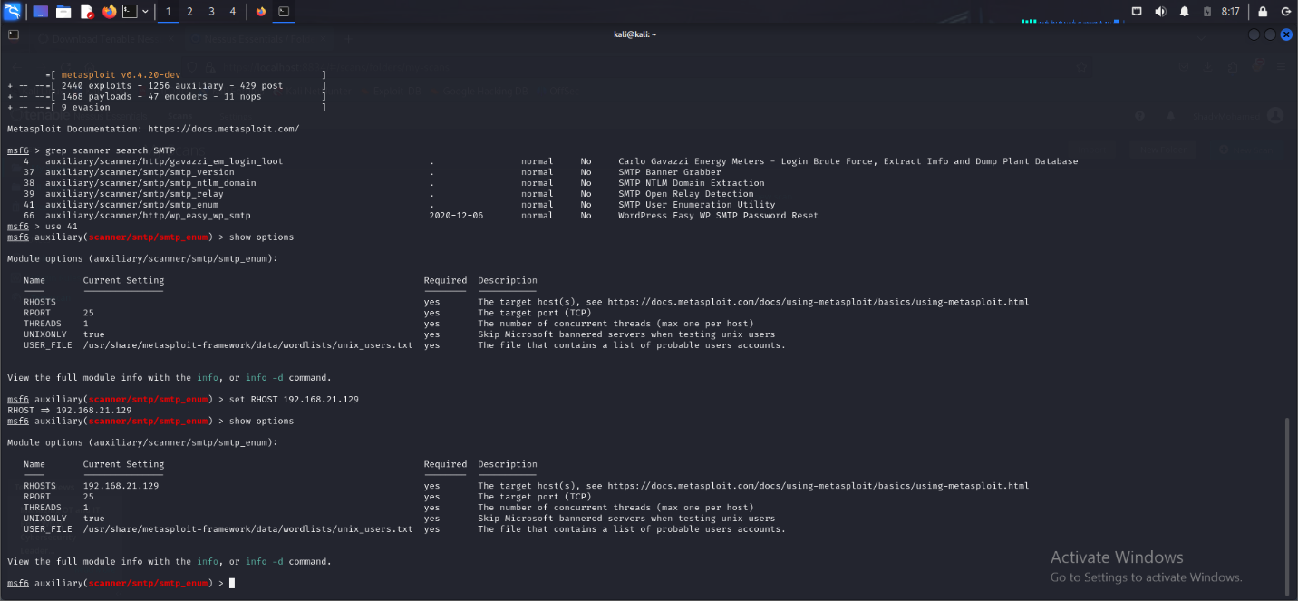

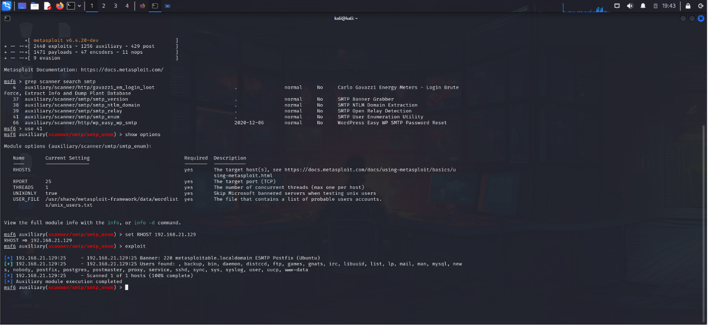#

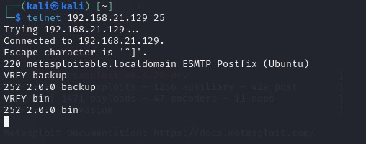

**mitigation**

To secure SMTP on port 25/TCP, the following measures are recommended:

* **Implement strong authentication** mechanisms (e.g., SMTP AUTH) to prevent unauthorized access.
* **Enable anti-spam and anti-malware filtering** to block malicious emails.
* R**egularly update** SMTP server software to patch vulnerabilities.

**2.HTTP on port 80/tcp:**

**The first step is to identify the HTTP server version and any running web applications. By scanning port 80 using nmap or directly connecting to the web service using a browser, we can gather information such as:**

* **The web server software (e.g., Apache)**
* **Web application versions**
* **Directory structures**

**Next, we use Metasploit to search for any vulnerabilities that can be exploited, such as: Directory Traversal: This could allow us to access files and directories outside of the web root.**

**We should show option because sometimes we find the options that are required to make the exploit.**

**We found “RHOST” that required and no value in here, so we should set the “RHOST” option by the target machine.**

**And exploit this payload.**

**This problem may allow an attacker to Directory Traversal**

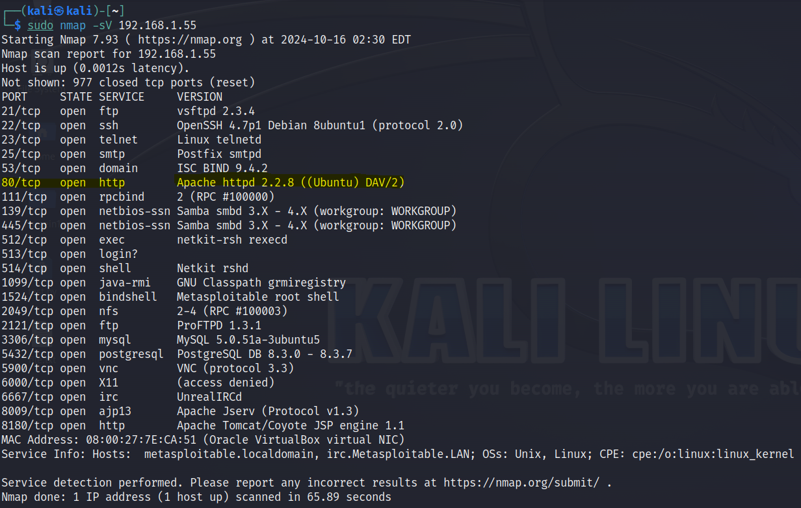

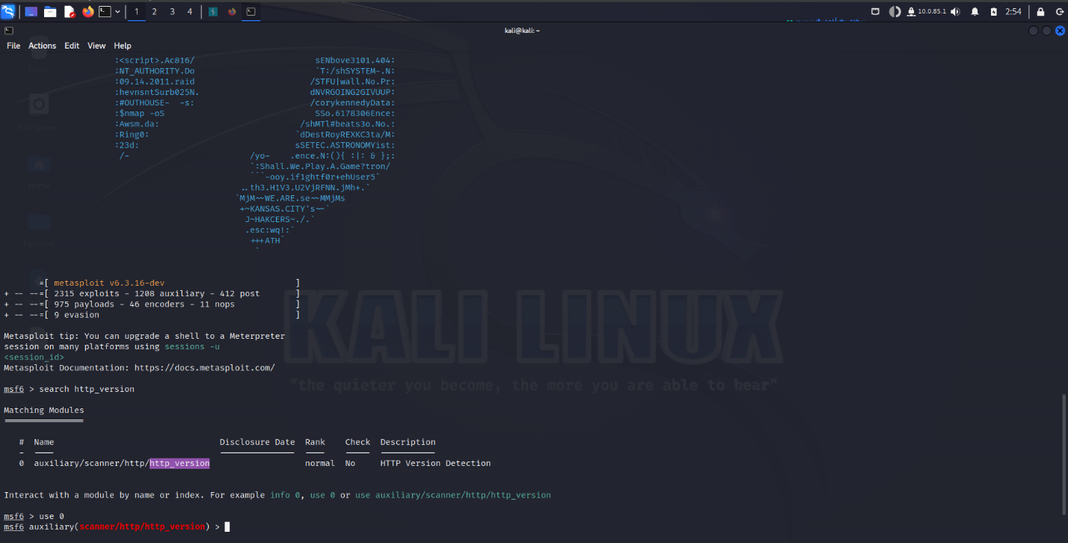

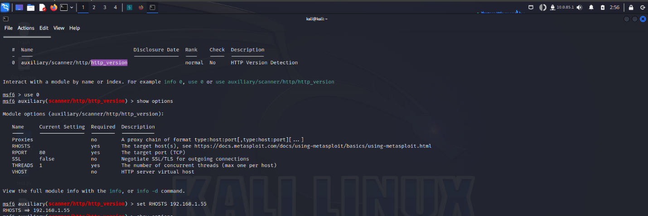

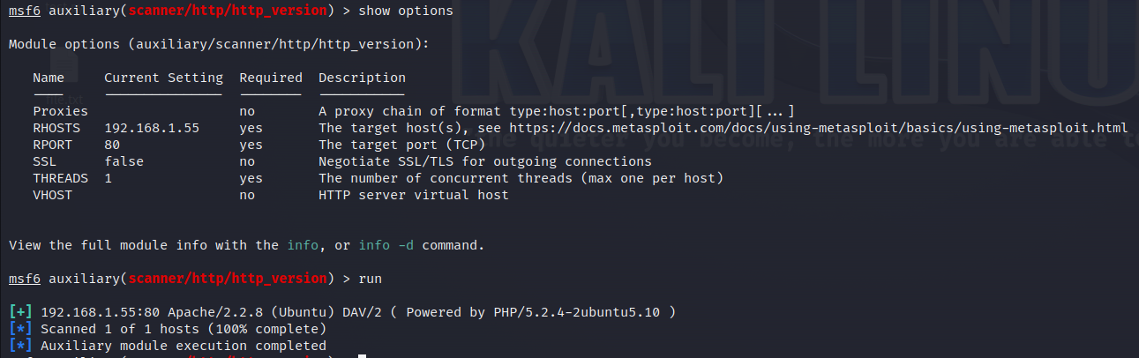

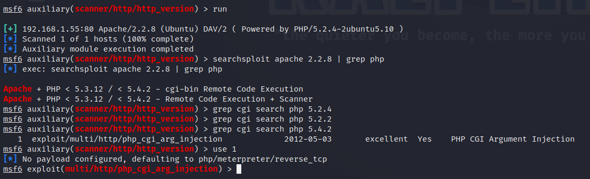

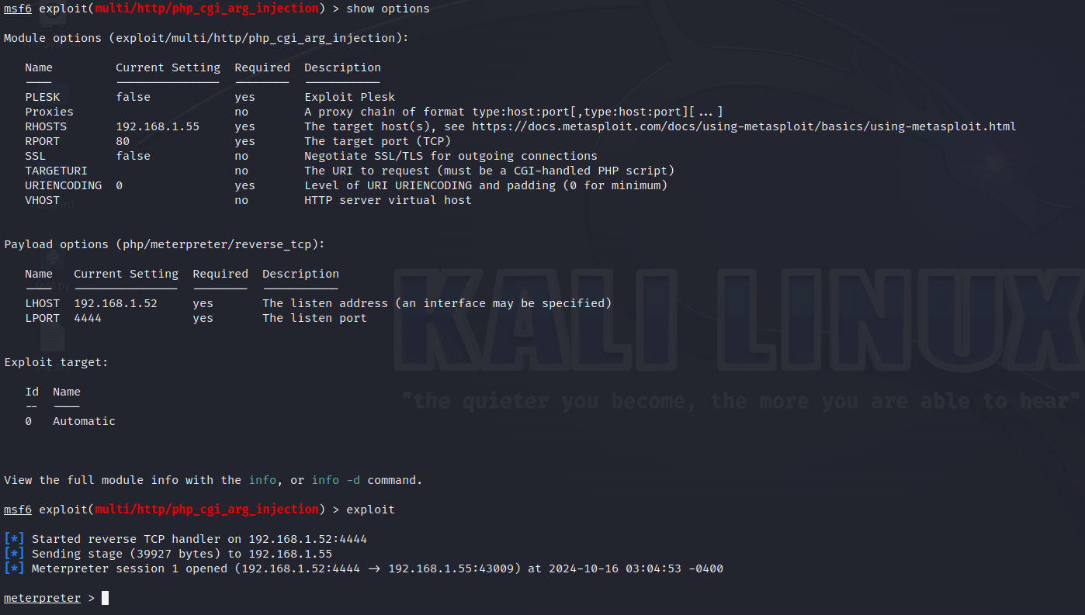

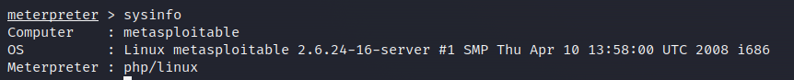

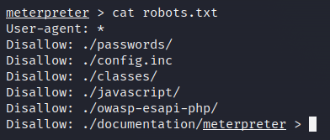

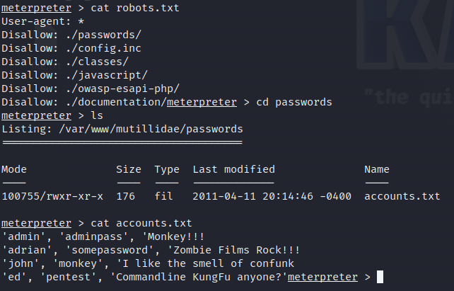

So I can access the password file and get the email and password of the users

**mitigation**

To secure HTTP on port 80/TCP, implement the following steps:

* **Migrate to HTTPS** by using SSL/TLS certificates to encrypt web traffic.
* **Enforce HTTPS** redirection to ensure secure communication.
* **Regularly patch and update** web servers and applications to prevent exploitation.

**3.vnc on port 5900/tcp:**

**Virtual Network Computing (VNC) services. Due to misconfigurations or weak security settings, we were able to exploit this service and gain unauthorized access to the target machine. This vulnerability allowed us to remotely control the system, highlighting a critical security risk that must be addressed to prevent further unauthorized access.**

**We use grep to show the scanner type and then we’re going to search VNC.**

**And after this, we use the VNC_Login**

**We should show option because sometimes we find the options that are required to make the exploit.**

**We found “RHOST” that required and no value in here, so we should set the “RHOST” option by the target machine.**

**And exploit this payload.**

**we get into their machine due to its vulnerability.**

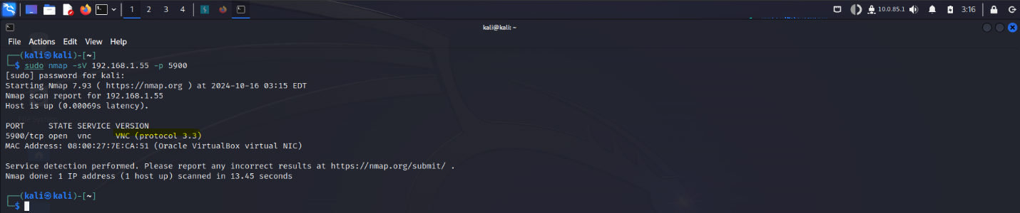

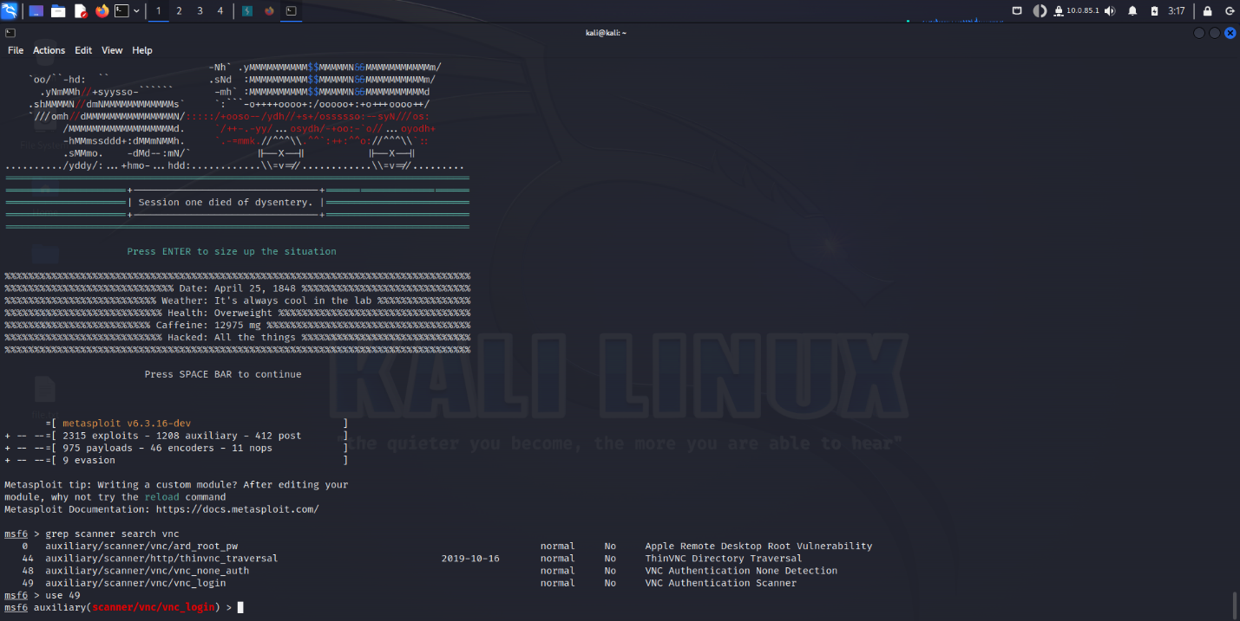

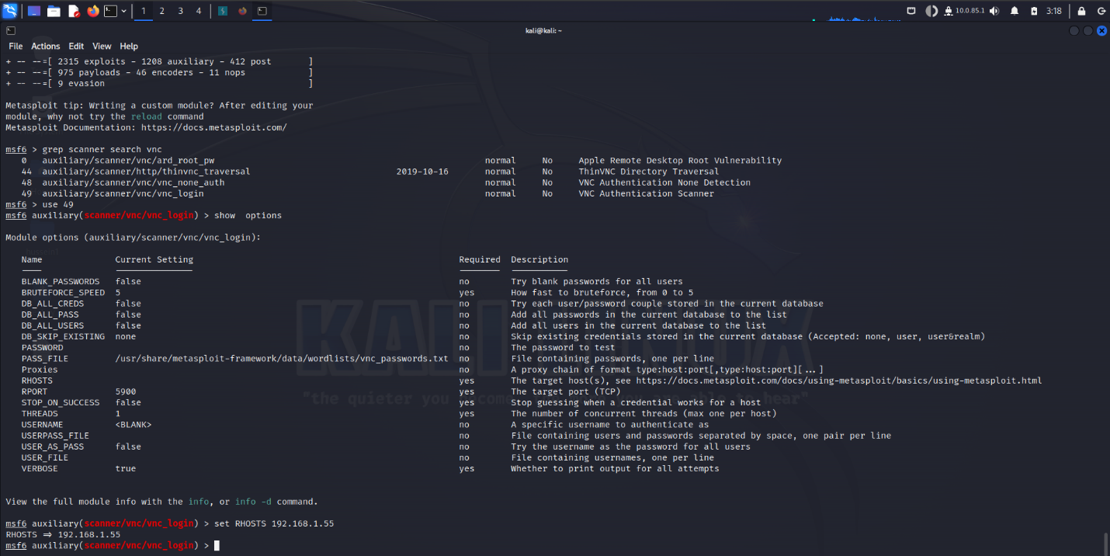

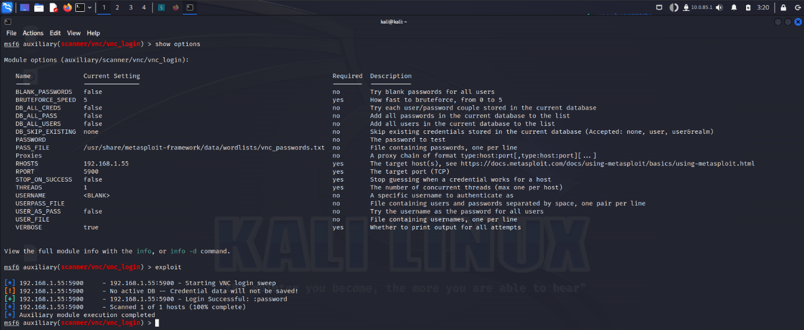

**mitigation**

To mitigate the VNC vulnerability on port 5900/TCP, the following steps are recommended:

* **Disable VNC if not needed** to reduce attack surface.
* **Use strong passwords** and avoid default credentials.
* **Encrypt VNC traffic** with SSH tunneling or VPN.
* **Restrict access** with firewall rules to trusted IPs.
* **Update VNC software** regularly to patch vulnerabilities.
* **Enable multi-factor authentication (MFA)** for added security.
* **Monitor access logs** for suspicious activity.

**4.** **MYSQL on port 3306/tcp:**

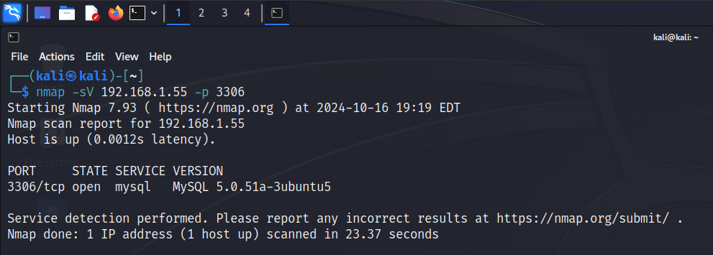

First I use nmap to see the service in the port

Then open Metasploit

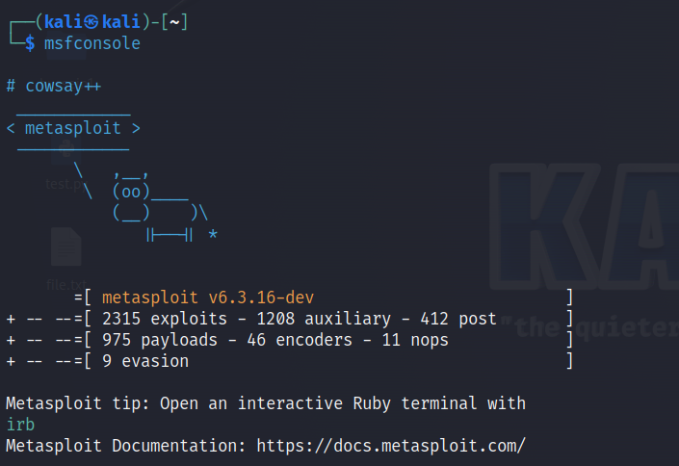

We use grep to show the scanner type and then we’re going to search mysql_login.

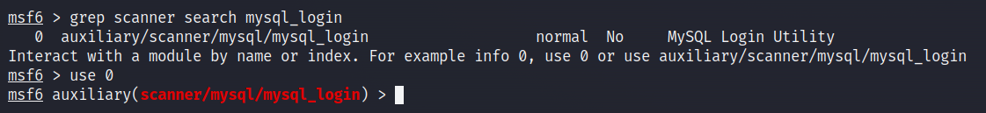

Then show options to see what’ss needed

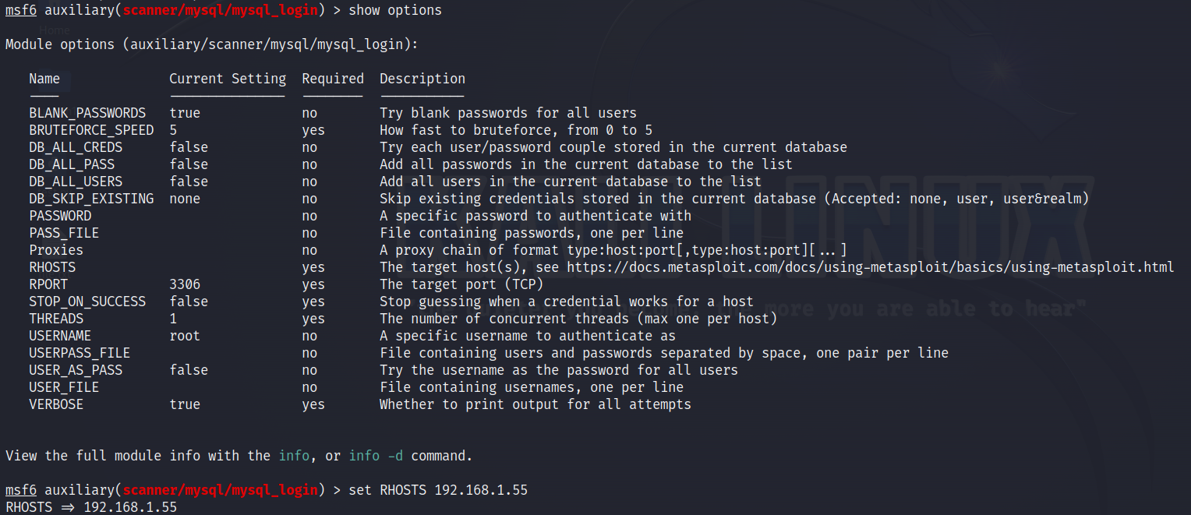

Then use the exploit

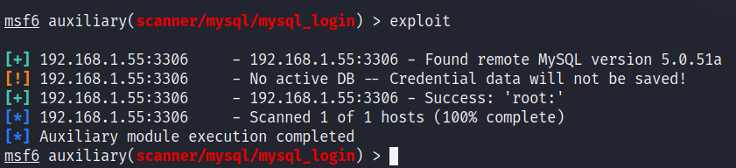

Then use the root without password to enter to the sql

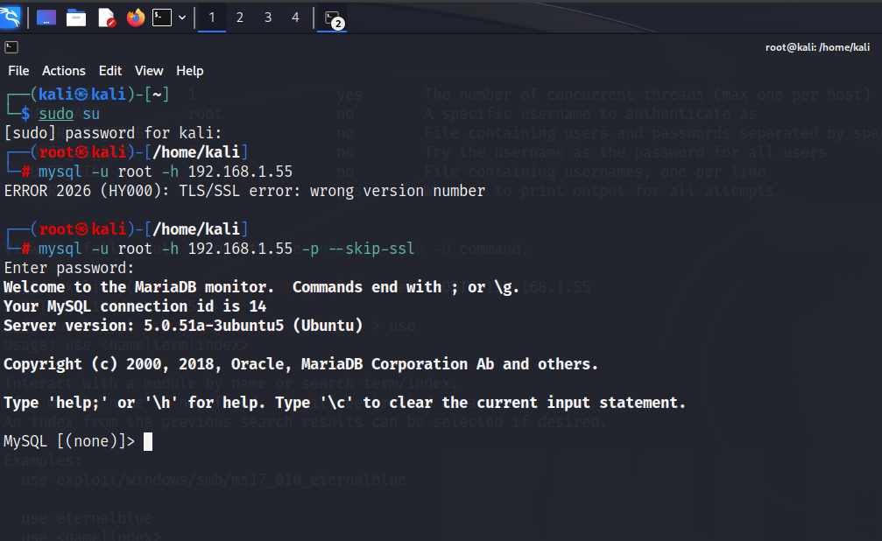

This error massage maybe because of SSL/TLS Version Mismatch (The MySQL client is trying to connect to the server using an unsupported or incorrect version of TLS/SSL.) Or SSL/TLS Not Configured Properly or Incompatible MySQL Client and Server (Different versions of MySQL/MariaDB (server vs. client) may have incompatible SSL/TLS settings.)

**mitigation**

To secure MySQL on port 3306/TCP, the following measures are recommended:

* **Restrict remote access** by limiting connections to trusted IP addresses.
* **Enforce strong authentication** with complex passwords and avoid default credentials.
* **Regularly update MySQL** to the latest version to patch vulnerabilities.

**5.** **PostgreSQL on port 5432/tcp:**

After we done the nmap scan we find

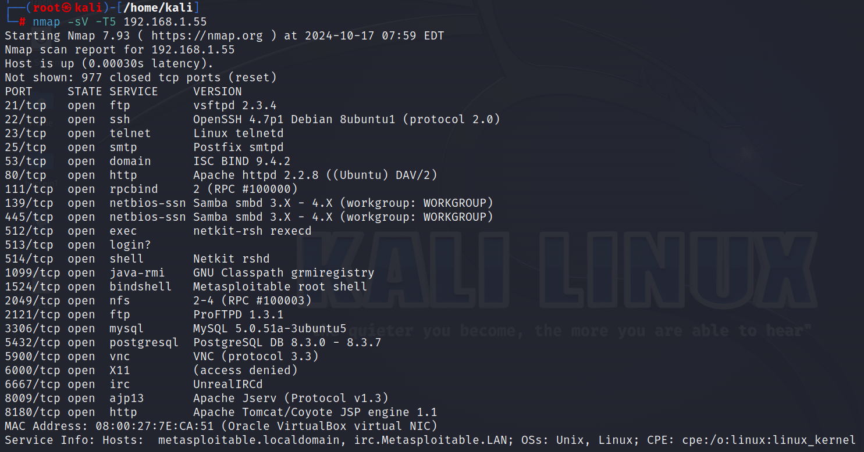

And after that we open metasploit

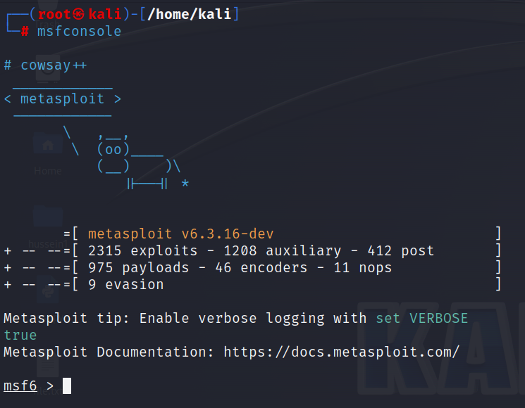

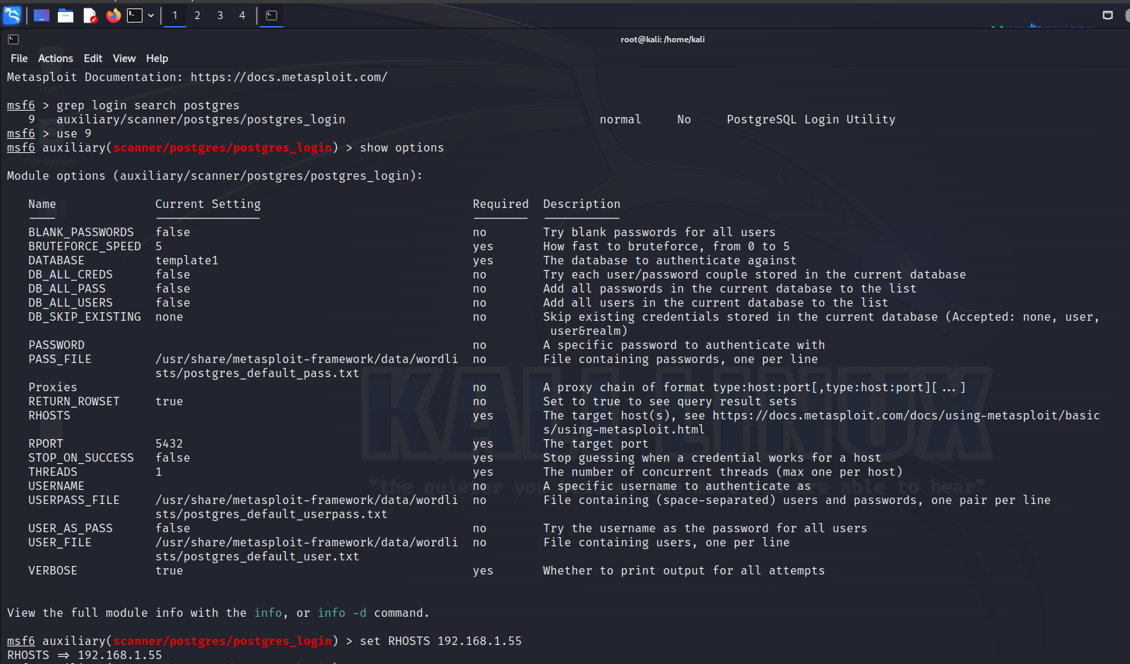

We use grep to show the scanner type and then we’re going to search postgres and after this, we use the postgres_login

We should show option because sometimes we find the options that are required to make the exploit.

We found “RHOST” that required and no value in here, so we should set the “RHOST” option by the target machine. And exploit this payload.

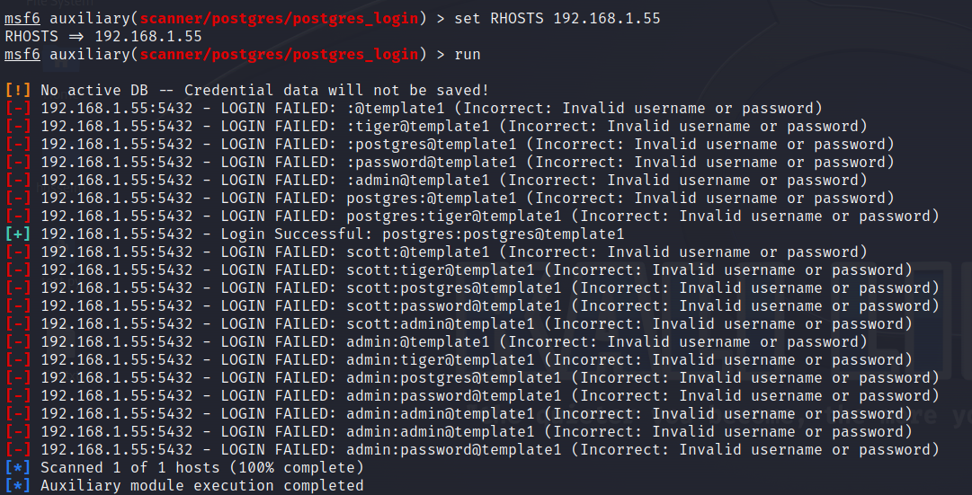

So we got successful login in it

**mitigation**

To secure PostgreSQL on port 5432/TCP, implement the following measures:

* **Restrict remote access** by allowing connections only from trusted IP addresses.
* **Use strong passwords** and avoid default credentials for authentication.
* **Regularly update PostgreSQL** to ensure the latest security patches are applied.
* **Limit user privileges** to follow the principle of least privilege.

**6.ftp on port 21/tcp:**

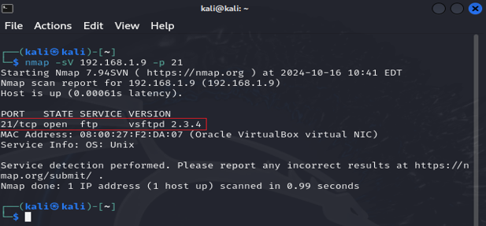

Through an Nmap scan, we discovered that port 21 is open and running the FTP service, specifically version vsftpd 2.3.4.

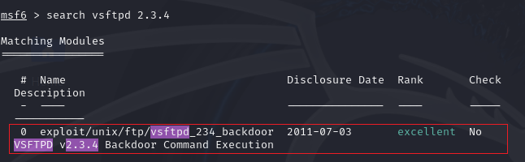

After searching Metasploit for that version, it appears that this version is vulnerable.

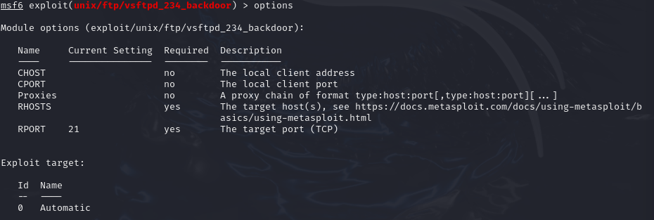

These are the required options: we will add the RHOSTS, which is the IP address of the vulnerable machine.

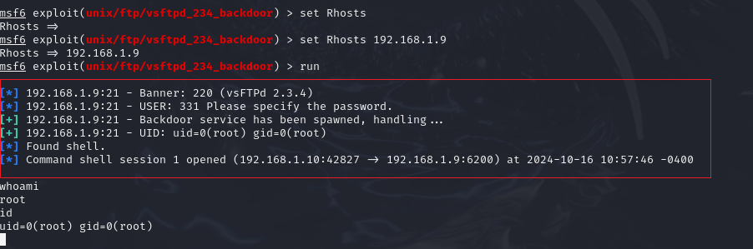

After running the exploit, we successfully gained a shell on the machine and now have control over it.

**mitigation**

To secure FTP on port 21/TCP, consider the following actions:

* **Disable FTP** and use **SFTP or FTPS** for secure file transfers.
* **Enforce strong authentication** with complex passwords and disable anonymous access.
* **Regularly update FTP software** to address security vulnerabilities.

**7.SSH on port 22/tcp:**

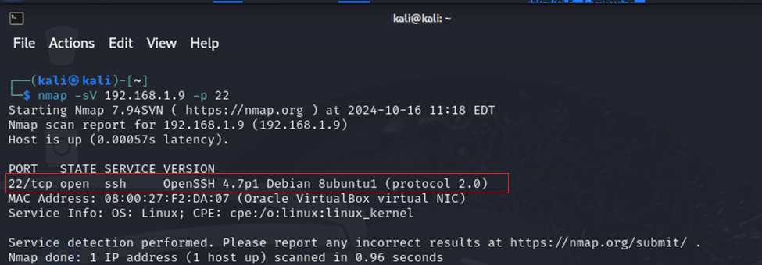

Through an Nmap scan, we discovered that port 22 is open and running the SSH service, specifically version OpenSSH 4.7p1.

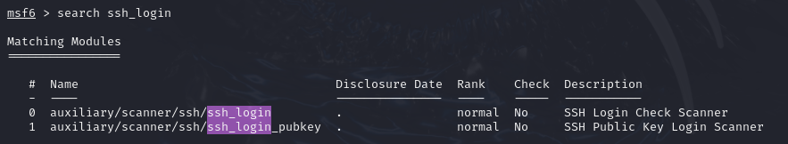

After searching Metasploit for SSH brute-force login modules, we found two options and will proceed with using the first one.

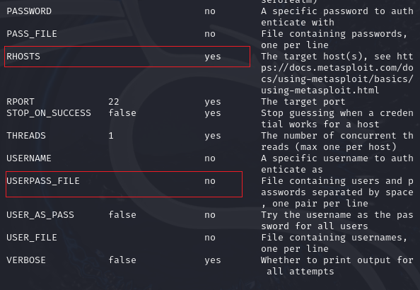

These are the required options: we will add the RHOSTS, which is the IP address of the vulnerable machine, and the USERPASS_FILE, which is a wordlist containing potential usernames and passwords.

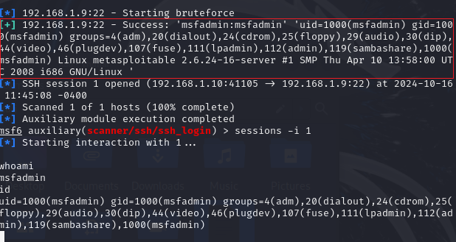

After running the exploit, we successfully gained a shell on the machine and now have control over it.

**mitigation**

To secure SSH on port 22/TCP, the following measures are recommended:

* **Use key-based authentication** instead of passwords for stronger security.
* **Disable root login** to minimize risks.
* **Change the default port** from 22 to a non-standard port to reduce attack exposure.
* **Implement firewall rules** to restrict SSH access to trusted IP addresses.
* **Enable two-factor authentication (2FA)** for added security.

**8.** **Telnet on port 23/tcp:**

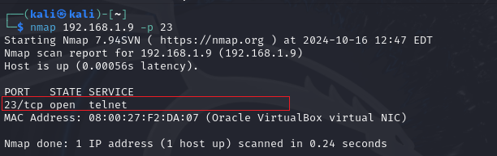

Through an Nmap scan, we discovered that port 23 is open and running the Telnet service.

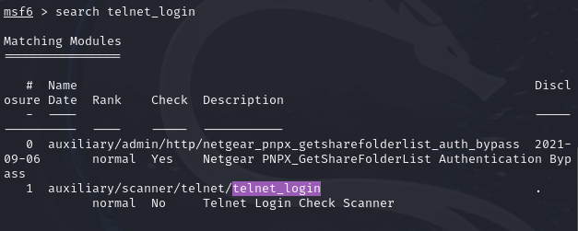

After searching Metasploit for Telnet brute-force login modules, we found two options and will proceed with using the second one.

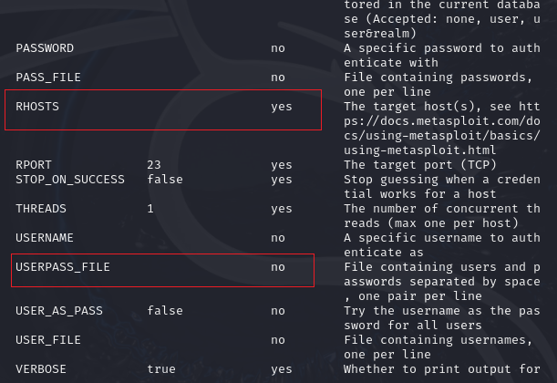

These are the required options: we will add the RHOSTS, which is the IP address of the vulnerable machine, and the USERPASS_FILE, which is a wordlist containing potential usernames and passwords.

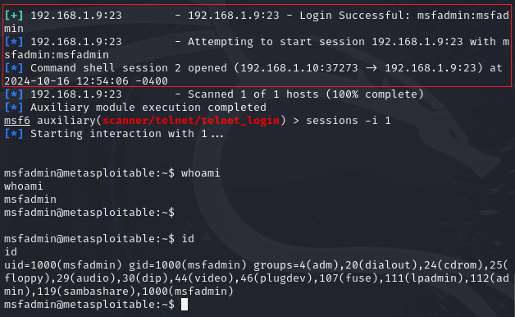

After running the exploit, we successfully gained a shell on the machine and now have control over it.

**mitigation**

To secure Telnet on port 23/TCP, the following actions are recommended:

* **Disable Telnet** and replace it with **SSH** for secure communication.
* **Use strong authentication** and complex passwords to prevent unauthorized access.
* **Encrypt traffic** using a VPN or an encrypted tunnel since Telnet transmits data in plain text.
* **Regularly update** any systems using Telnet.
* **Monitor logs** for suspicious login attempts and unusual activity.

**9.Apache Tomcat Default Credentials Port 8180:**

Running Nmap on Metaspoitable2 IP can see that 8180 port is open and running tomcat service on that.

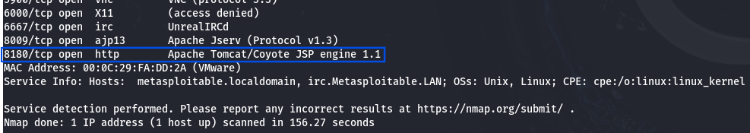

Try opening the page on port 8180 with url http:metasploitableIP:8180

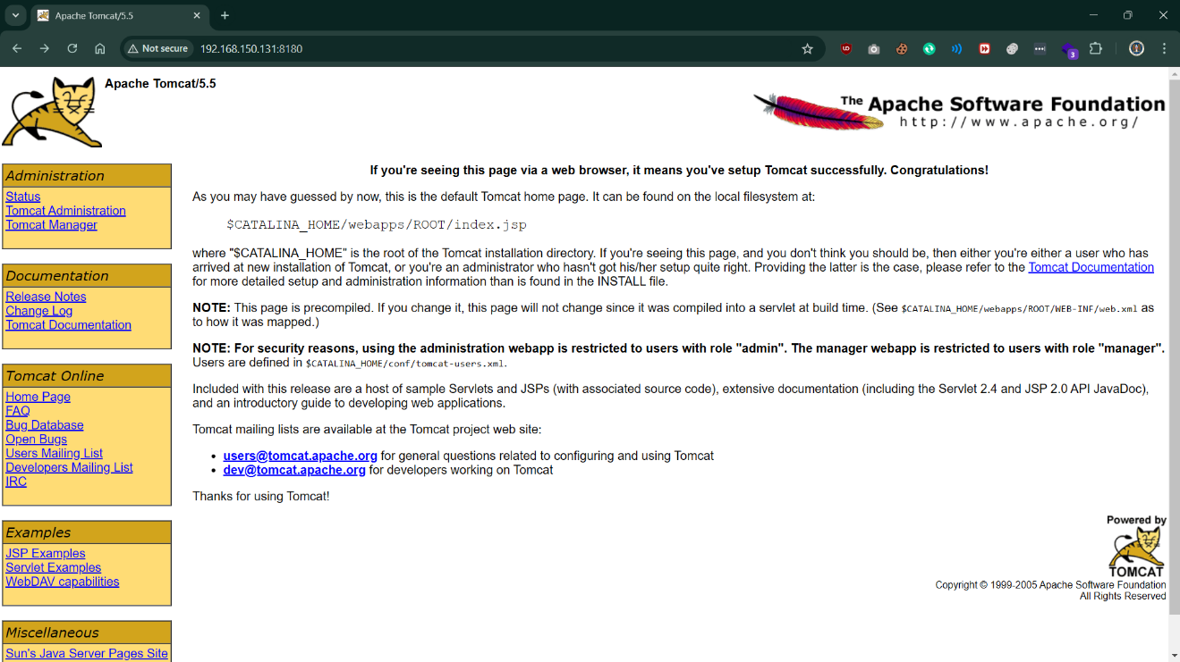

When you will click on any of the links in left panel, it will ask to login.

Now let’s move to Metasploit to see if there is an exploit to get login credentials in msf.

Now, we have an exploit in msf to get the login credentials:- auxiliary/scanner/http/tomcat_mgr_login

Use this exploit and set the options:-

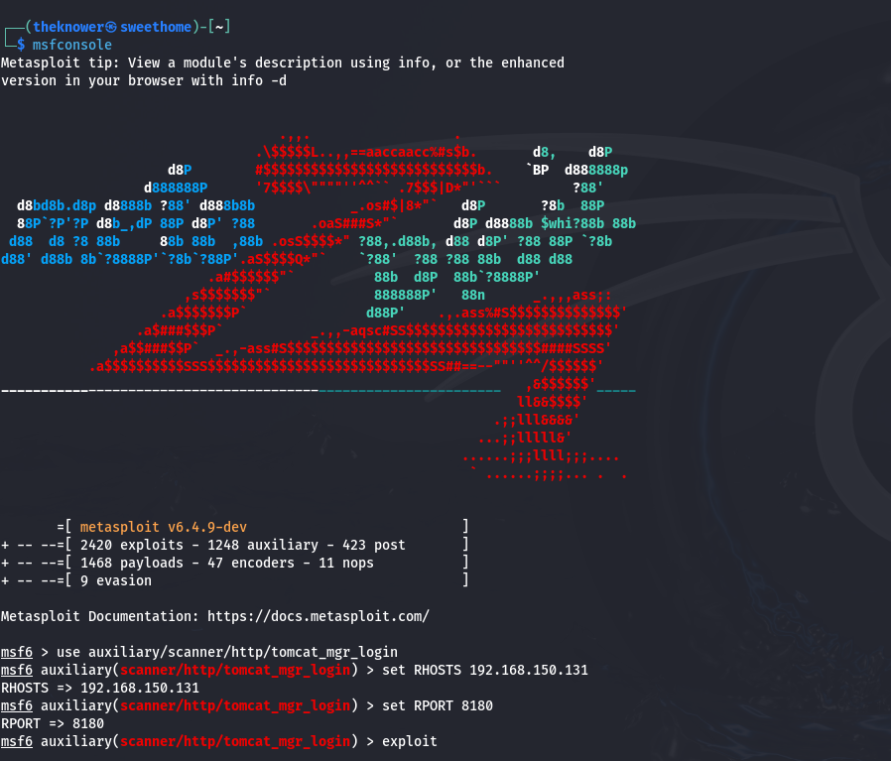

Now we set the RHOST and the RPORT and enter exploit.

After we did the bruteforce and finished exploiting we found the login credintials.

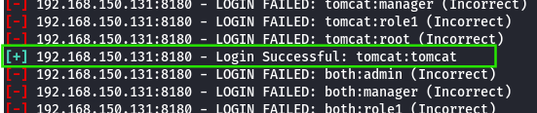

We will use these credentials to login to the Apache page.

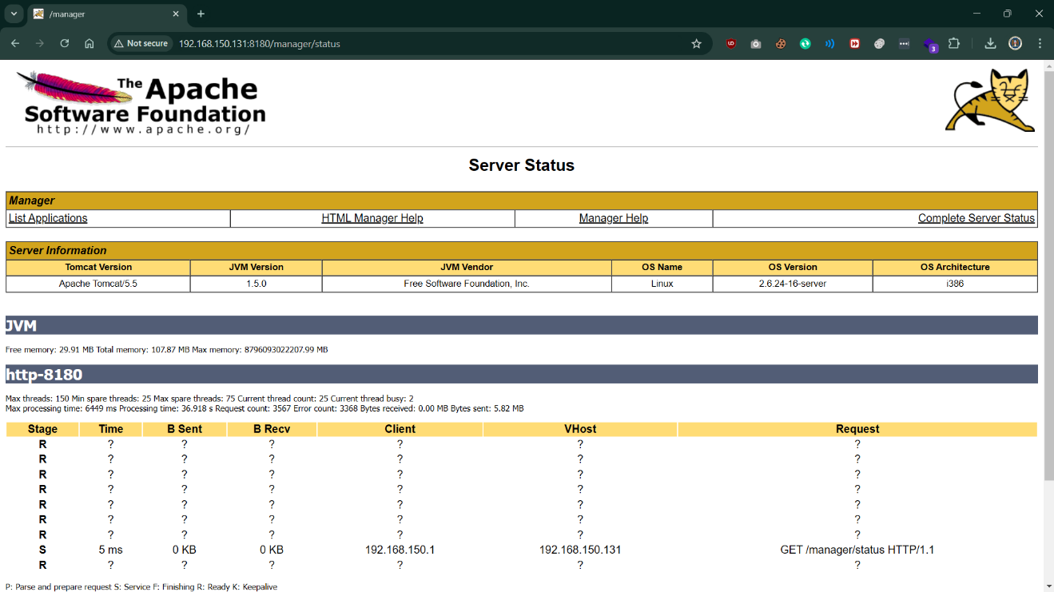

Click on ‘List Applications’ under Manager tab, and you will see there are couple of options to upload the file.

Now we can try exploiting upload vulnerability on this one, either using the exploit available on msfconsole or creating an exploit using msfvenom.

**Mitigation**

**Now to avoid this exploitation we recommend to get the latest updates and update the version if possible and don’t use default login credentials and avoid using weak passwords.**

**10.** **Samba smbd 3.X on port 139:**

As we can see, the target is using Samba version 3.0, which allows an attacker to execute arbitrary commands, by specifying a username containing shell meta characters.

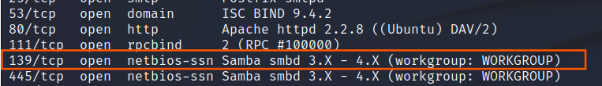

We are going to use the Metasploit framework to search for exploit in msfconsole.

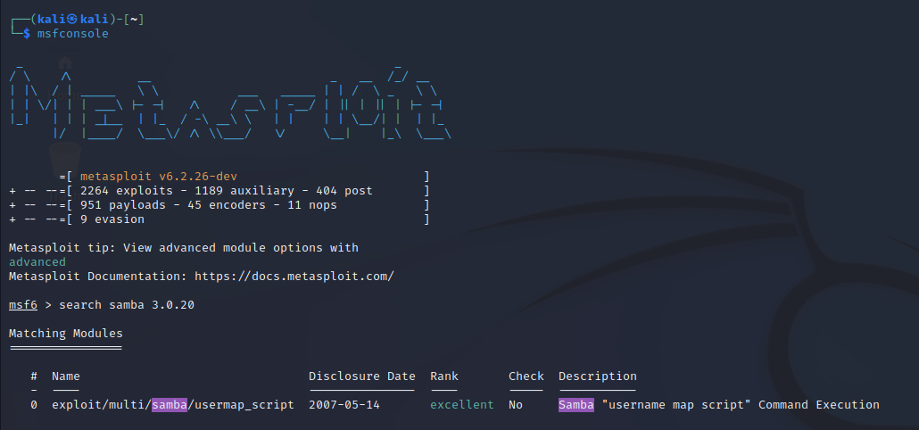

Now we found exploit for this version, and we are going to use it.

Now we set our target:

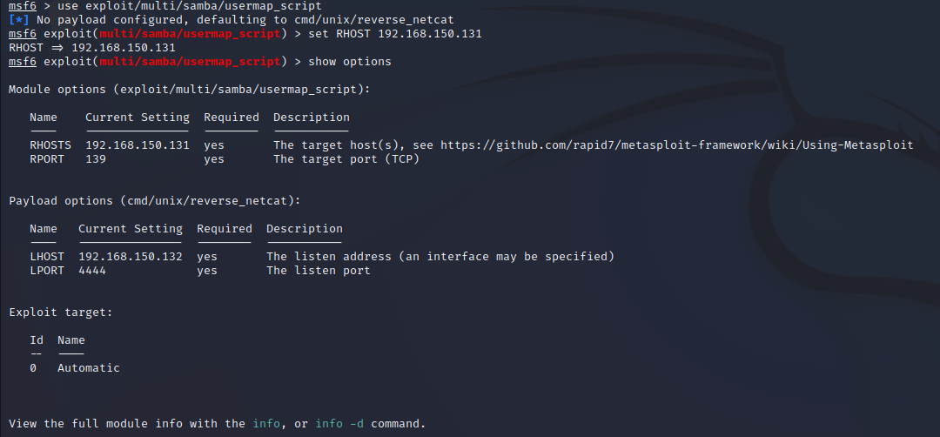

This automatically gives us a root shell, where we can execute commands and dig further in the target machine.

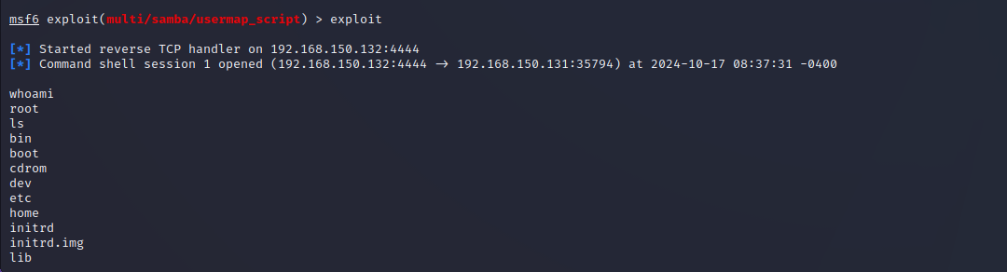

**Mitigation**

To secure Samba smbd 3.X on port 139, consider the following actions:

* **Update Samba** to the latest version to patch known vulnerabilities.

**11. Java RMI (Remote Method Invocation) Server:**

The Java Remote Method Invocation (Java RMI) is a Java API that performs remote procedure calls (RPC).

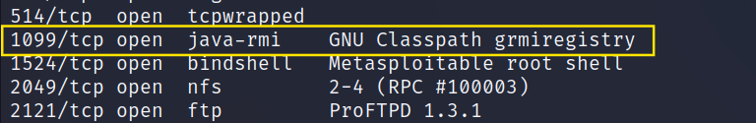

Now let’s look at the Metasploit and search for any available exploit for it.

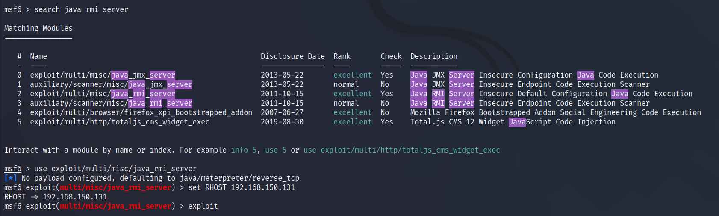

Now we found these exploits and will use this exploit/multi/misc/java_rmi_server.

We set the target machineIP and exploit.

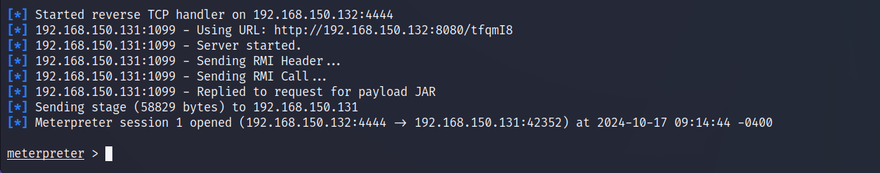

And now we have remote control access on it.

**Mitigation**

To secure a Java RMI server, consider the following measures:

**Regularly update the Java Runtime Environment (JRE)** to apply the latest security patches.

**Implement strong authentication** to ensure that only authorized clients can access the server.

**12.** **Detected Backdoor in IRC on Port 6667 (not exploited):**

In this part, we will talk about a vulnerability service that is called unrealircd. Unrealircd is the irc server. The version at that time was a backdoored.

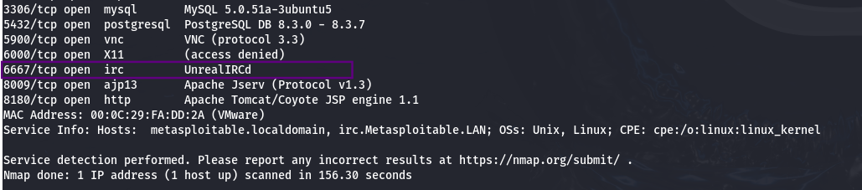

IRC is short for Internet relay chat, the most famous chat system. IRC works on application layer that serve communication in text.

The standard port is TCP 6667.

Now as usual we’re going to open Metasploit and search for any available exploits for it in msf.

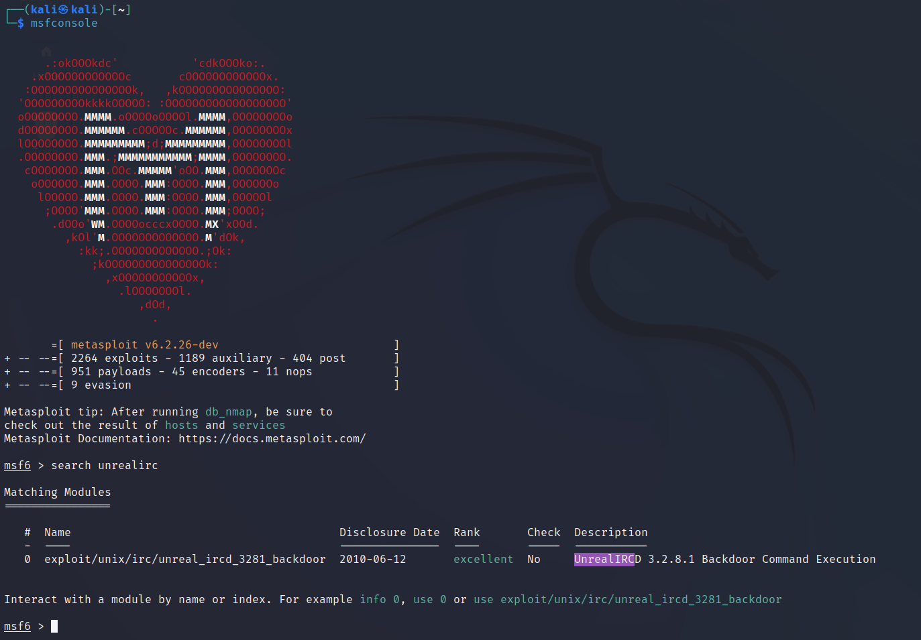

We are going to use this exploit exploit/unix/irc/unreal_ircd_3281_backdoor

Now we set The RHOST and RPORT for the targeted machine and exploit it.

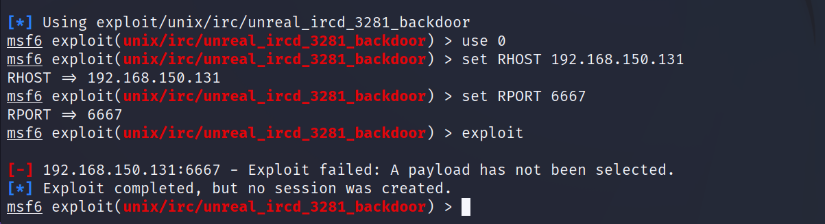

As we see, unfortunately the exploit successfully completed, but no session was created.

This may be due to not any more using old versions and fix the exploit by now.

**13.** **Bind Shell on port 1524/TCP:**

* We use nmap with the option -sV to identify the software version running on port 1524 and find port 1524 open and running a bind shell which we try to exploit

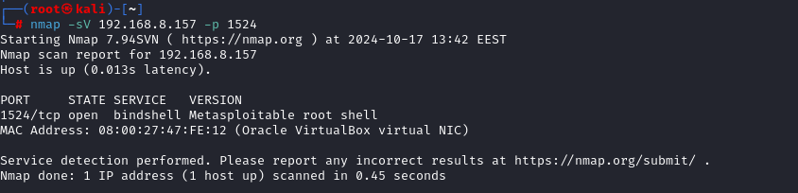

We use netcat which initiates a connection on the ip of the machine and the port open

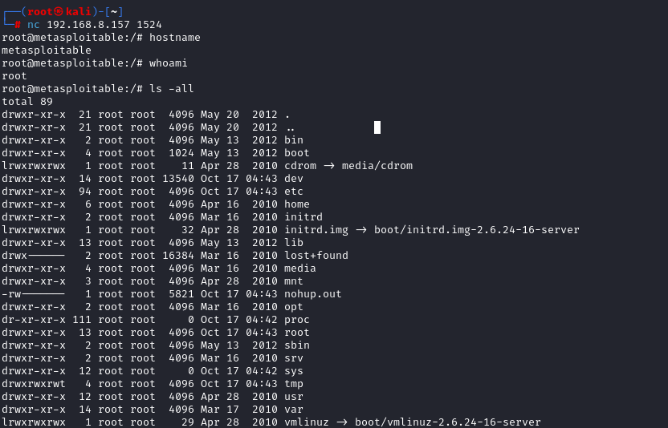

And we are in as root



**Mitigation**

To secure a bind shell on port 1524/TCP, implement the following measures:

* **Disable the bind shell** if it is not necessary for operational purposes to reduce attack surface.
* **Restrict access** by using firewall rules to allow connections only from trusted IP addresses.
* **Use strong authentication** and enforce complex passwords to prevent unauthorized access.